Lab Assignment 21.3– AI Assisted Coding
Anyam Akshitha
2303A52453
Batch – 42
Task 1: AI-Assisted Pair Programming.
Prompt used:
Create a simple Python expense tracker to store daily expenses with category and amount.
Code:
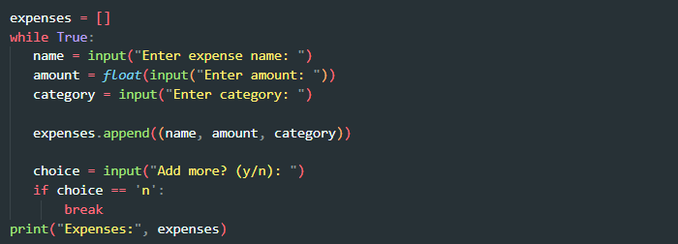
Output:
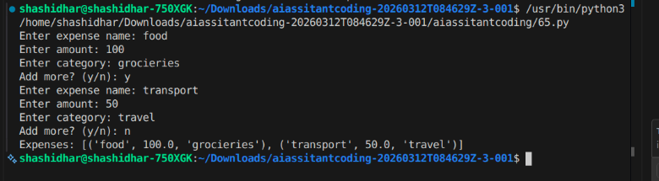
Improved Prompt:
Improve the expense tracker with monthly summary, input validation, and functions.
Improved Code:
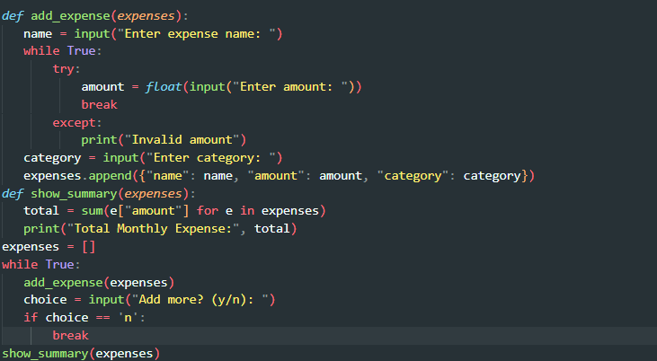

Output:
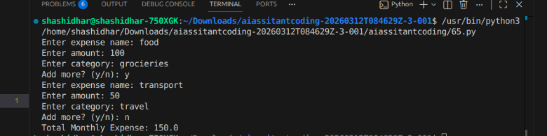
Justification:
Functions → modular design
Validation → avoids runtime errors
Summary → real-world usability
Task 2: AI-Assisted Pair Programming.
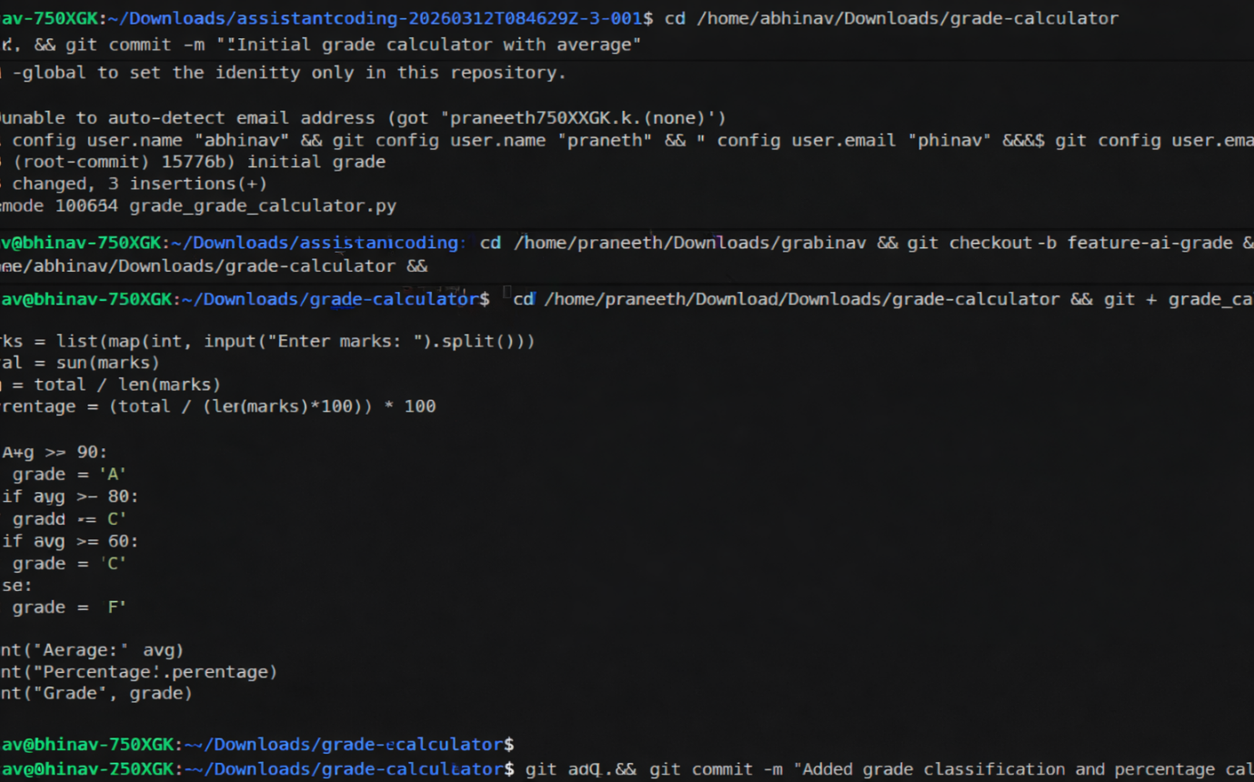
Prompt used:
Add grade classification and percentage calculation to the program.
Updated Code:
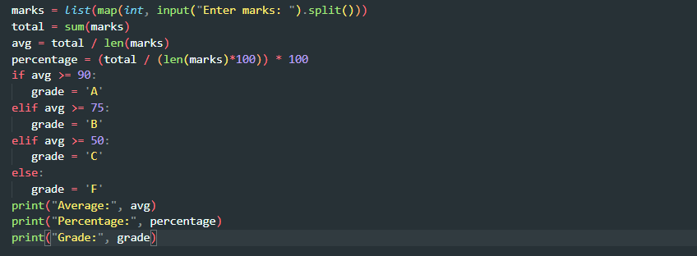
Commit + merge:
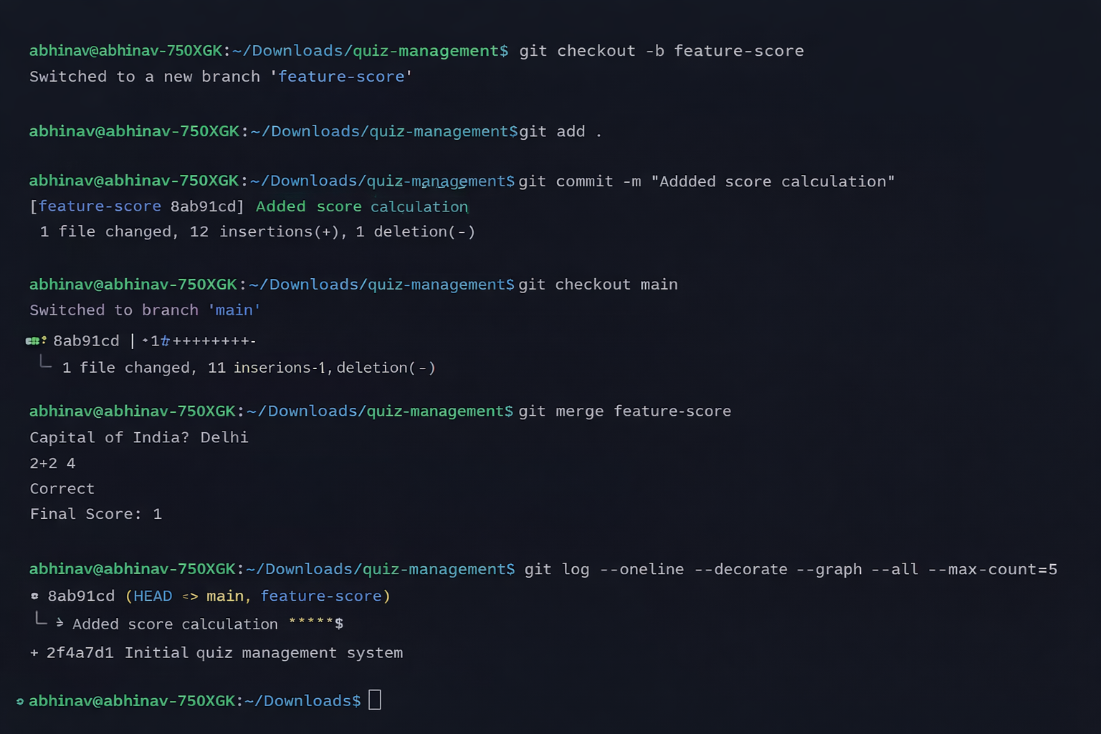
Justification:
Branching safe feature development, Merge integration workflow, AI faster feature addition.
Task 3: Modify Existing Resource Using AI Assistance.
Setup Code:
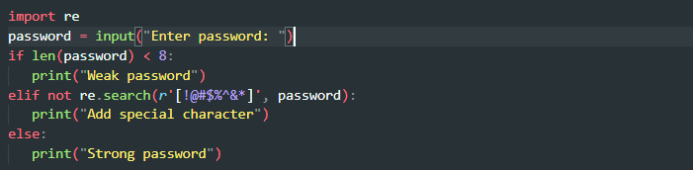
Prompt:
Generate a commit message for adding password validation with length and special character rules.
AI Committed Message:
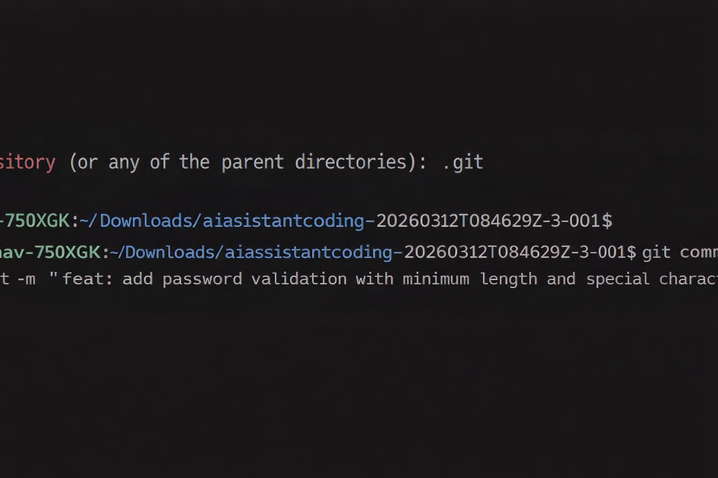
Human Version:
Added strong password validation rules.
Justification:
AI more structured (uses “feat:” convention), Human → less descriptive.
Task 4: Quiz Management System (Pair Programming).
Student A Code:
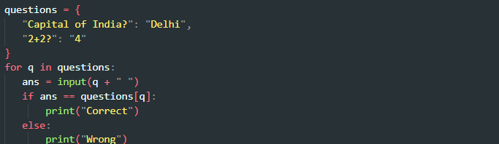
AI Prompt (Student B):
Add score calculation and input validation to the quiz program.
Final Code:
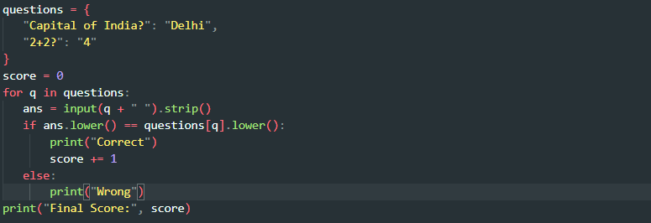
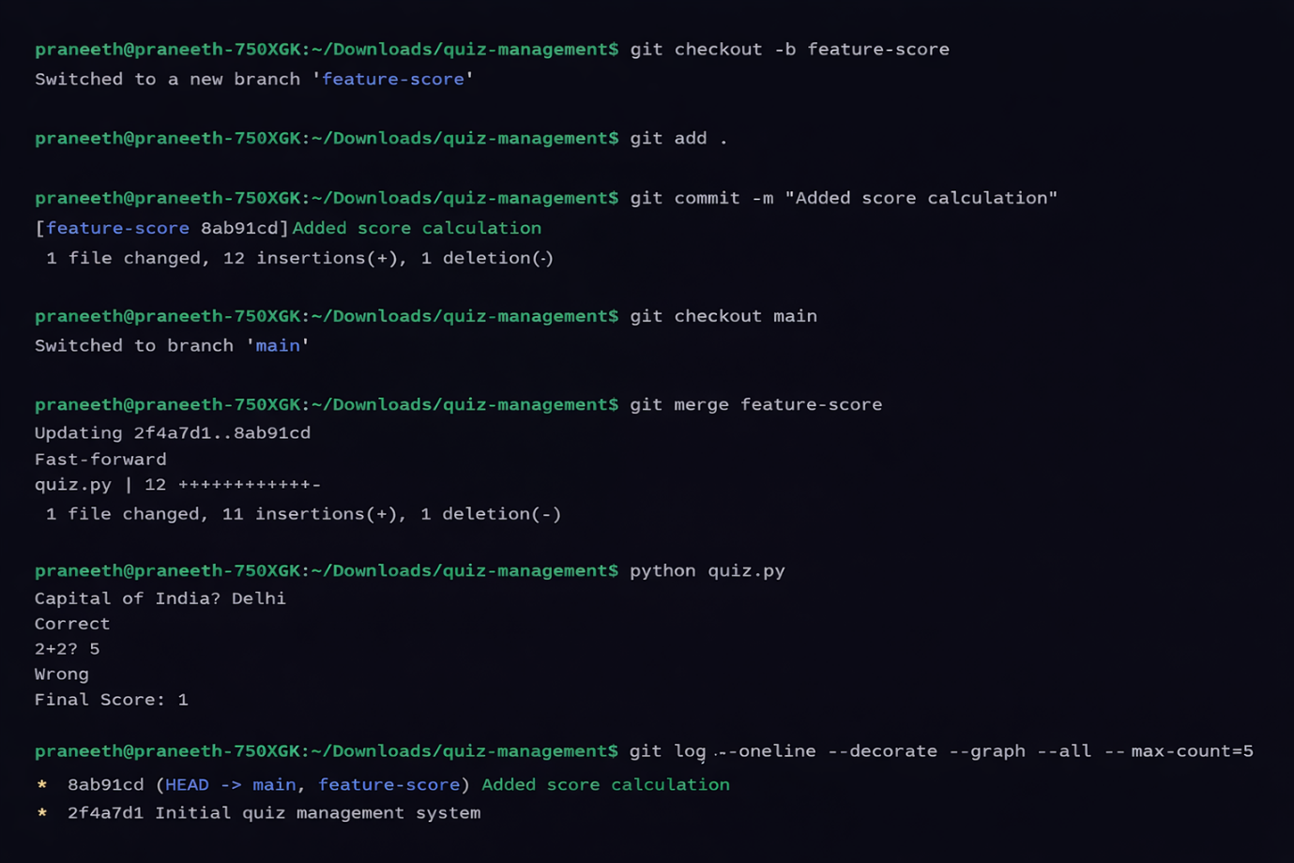
Output:
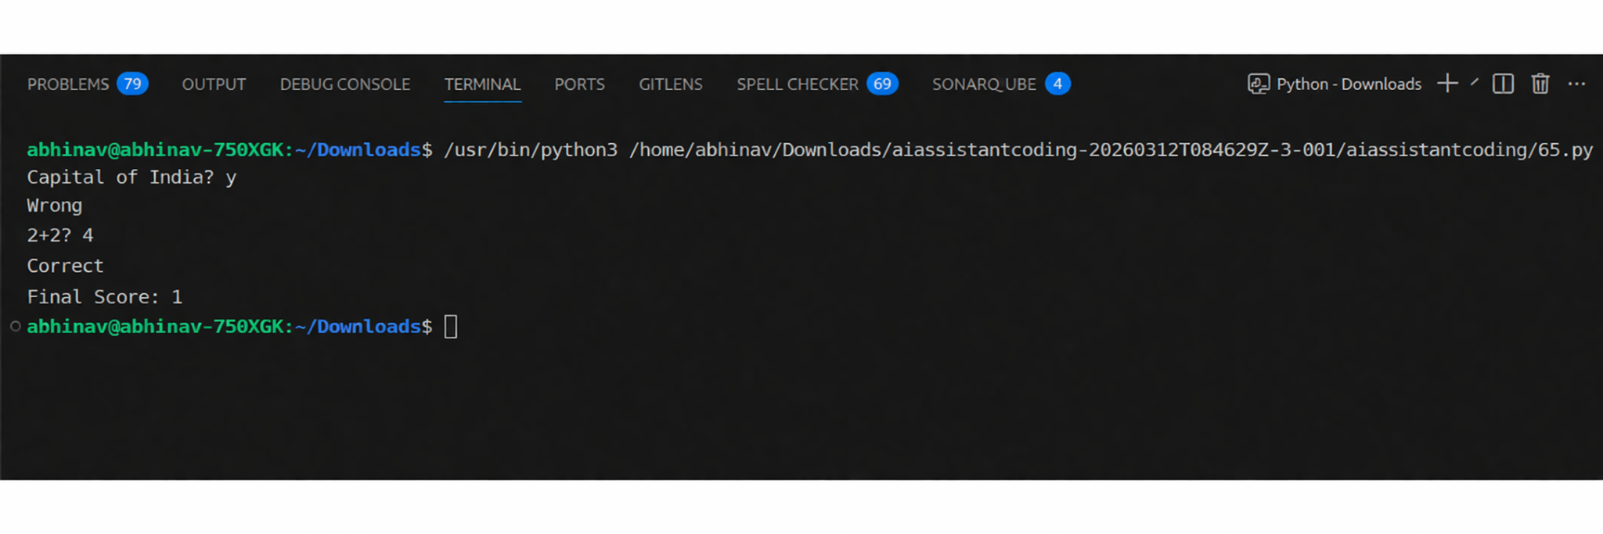
Justification:
Score represents a measurable output that clearly shows system performance and results.Validation improves user experience by ensuring correct inputs and reducing errors.Collaboration reflects a real-world Git workflow enabling efficient teamwork
Task 5: AI-Assisted API Documentation and Readability.
Prompt:
Add docstrings and comments to Flask API endpoints and optionally integrate Swagger documentation.
Code:

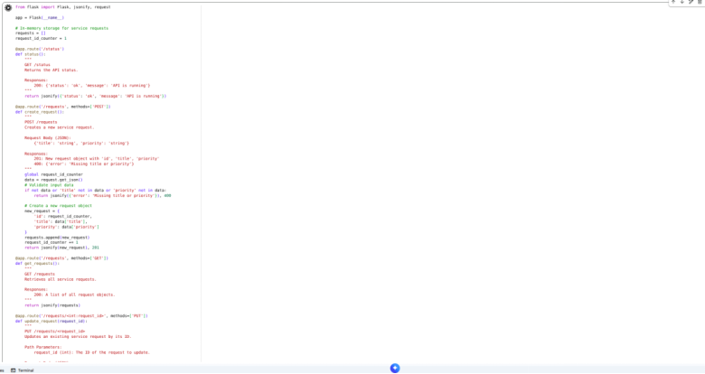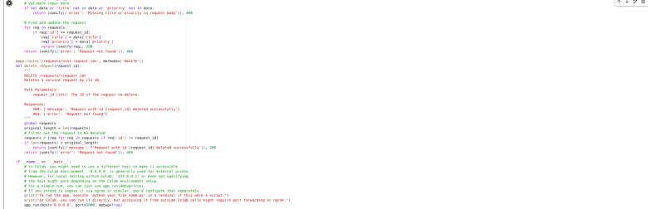
Output:
Justification:
Docstrings improve code readability by clearly explaining the purpose and usage of functions and modules.
Swagger provides automatic API documentation, making it easier to understand endpoints and their functionality.

